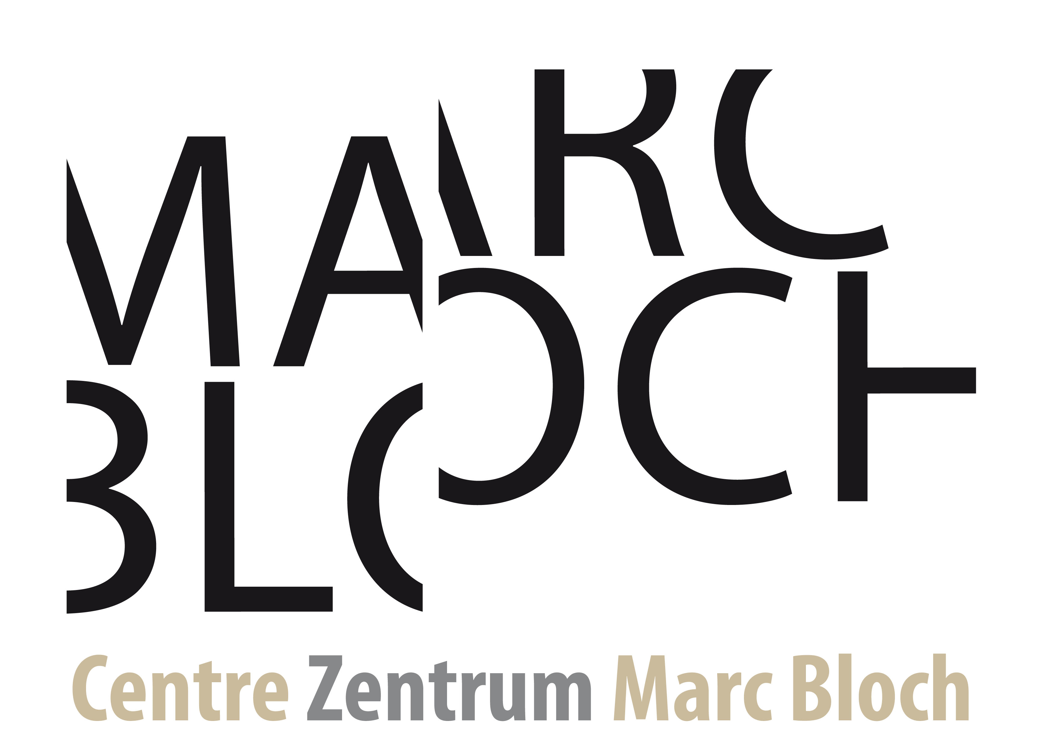

Call for projects of the Franco-German Research Fund on the Provenance of Cultural Objects from Sub-Saharan Africa

Submission Form

PROJECT TITLE:

Short project title (acronym, max 15 character):
Project duration (max. 36 months):
Discipline(s), research areas and keywords:

Project Coordinator:

Use an A4 layout, Calibri 11 or Arial 11, single-spaced, margins 2 cm or more, page numbering; for tables and figures, Calibri 9 or Arial 9 minimum.
The detailed proposal should be written in English and French OR in English and German and must:
1) comprise a maximum of 15 pages, including the scientific project, the Gantt chart, the budget table and the bibliography, in a single PDF document.
2) be accompanied by the following appendices in a single PDF document:
- Detailed budget
- CVs
using the templates available on the Fund's dedicated website.
Please draft your proposal in keeping in mind the evaluation criteria defined in the text of the call for projects available on the Fund's dedicated website.

Summary table of teams involved in the project
French team
Institution | Name | First name | Current position | Role and responsibilities in the project | Involvement over the duration of the project: percentage per working week (estimate)
 |  |  |  | Contact Person
German team
Institution | Name | First name | Current position | Role and responsibilities in the project | Involvement over the duration of the project: percentage per working week (estimate)
 |  |  |  | Contact Person
Sub-Saharan team
Institution | Name | First name | Current position | Role and responsibilities in the project | Involvement over the duration of the project: person.month or percentage per working week (estimate)
 |  |  |  | Contact Person

Context, positioning, and objectives of the project proposal

Research objectives and hypotheses
Describe the objectives, hypotheses and expected results of the research; explain the collaboration between museum research and academic research.

Positioning in relation to the state of the art
Demonstrate the innovative nature of the project, in terms of objectives and methodology and its position in relation to the state of the art.

Demonstrate the specific contribution of the Franco-German approach in dialogue with Sub-Saharan Africa.

If the project proposal is a continuation of a previous project, describe the new issues and objectives.

If applicable, list up to five past publications, realisations, or collaborations of the consortium.

1
2
3
4
5

Methodology and risk management
Describe the methodology and its relevance to achieving the stated objectives; discuss the feasibility of the project, the risks and the fallback solutions envisaged.
Describe the specific contributions of each institutional partner to the project objectives.
For research projects dealing with subjects that may impact humans, animals and/or the environment, describe the ethical aspects of the project. Please check national legislation and recommendations relating to research ethics.

Organisation and implementation of the project

Consortium
Present the project coordinator and his or her experience in terms of project coordination or management in the field covered by the project proposal.
Present the teams and how they complement each other, indicating the different skills mobilised for the completion of the project.
⚠ The CVs of the consortium members must be drawn up in accordance with the template that can be downloaded from the page dedicated to the call for projects and be included in the appendix.

Resources used and requested to achieve objectives
Describe the resources used and requested to achieve objectives.

    - Presentation of the context in terms of the human and financial resources, with particular reference to other ongoing projects and any current or future applications for funding.

    - Scientific and technical justification of the resources requested per major item of expenditure and per French team/German team, in line with the objectives of the project proposal.

    - Summary of the funding request: resources by major item of expenditure and by team.

One institution in Germany and one institution in France will receive and administer the funding.

Reminder: Funding requested must be in adequation with the project's objectives.
Budget
 | French team |  | German team
Staff costs
Fellowship and Internship allowances | For French team members: |  | For German Team members:
 | For Sub-Saharan partners: |  | For Sub-Saharan partners:
Travel expenses | For French team members: |  | For German Team members:
 | For Sub-Saharan partners: |  | For Sub-Saharan partners:
Scientific event organisation
Material expenses/ investments and small equipment (not exceeding 10% of the funding request)
Publication expenses
Communication expenses
 | Total French partner institution : € |  | Total German partner institution : €
Total benefitting Sub-Saharan African partner:  € | French partner:  € | German partner:  € |  | French and German partner:  €
GRAND TOTAL | €
Third-Party financing (optional)
 | Amount | Requested/obtained
Funding organisation | €
Funding organisation | €
Funding organisation | €
Total | €

Impact of the project
Highlight the added value of the project in terms of strengthening cooperation between all the partners and in terms of the Franco-German partnership; specify the integration of young researchers and young museum experts.
Describe the operations involved in promoting and disseminating research results, in the interest of transparency and in accordance with the FAIR principles (Findable, Accessible, Interoperable, Reusable), in scientific and expert arenas and to the public.

Bibliography
List references related to the project. The bibliography must be included in the scientific document, within the limit of 15 pages.

For example: Members of the scientific network (Project Coordinator; contact person, direct participant, team leader, workshop leader, other contributor…).
Applicants should always check whether an opinion of an ethics committee is required for their project.

